

Name: Apurba Koirala
Reg no: 22BCE3799
Subject Code: BCSE303P
Course Title: Operating Systems Lab
Lab Slot: L39 + L40
Guided By: Dr. Anto S
Lab Assessment 1.

Exercise 1 – Operating System Basics

Question – I

Demonstrate various Linux commands

ls: ls lists files and directories. The -l flag provides detailed information, including permissions, owner, size, and modification date.

cd: cd changes the current directory to the specified path.

mkdir: mkdir creates a new directory.

rmdir: the rmdir command removes empty directories

touch: touch creates a new file or updates the timestamp of an existing file
cp: cp copies files to a given location
mv: mv command moves or renames files or directories

rm: rm deletes files

pwd: gives full directory path of the current location in terminal

pushd: pushd command save the current directory on a stack and then changes to a new directory

popd: popd command returns the previous directory saved on the stack by pushd command

find: find command is used to search for files or directories within the filesystem

echo: echo command is used to display a line of text or a variable’s value on the terminal

cat: cat concatenates and displays the content of files

whereis: whereis command is used to locate the binary, source, and manual page files for a command

printenv: displays environment variables of the current shell

grep: is used to search for specific pattern within files or output

head: displays first few lines of a file

tail: displays last few lines of a file

OUTPUT SCREEN SHOT:

ls:
lists all directories
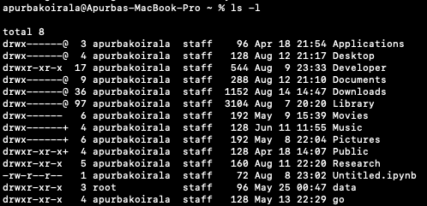

cd:
changes directory to ASD brain imaging which is inside Research directory

mkdir
makes a directory named test

rmdir:
removes the previously created test directory
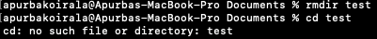

touch:
creates file named testfile.txt
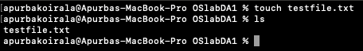

echo: a text is displayed on terminal window

cp:
copies previously created testfile.txt from directory OSlabDA1 to Documents
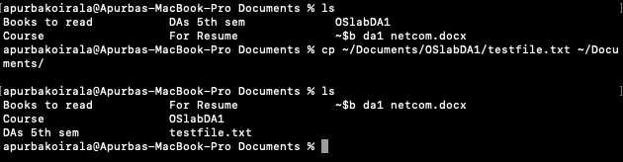

mv:
renames testfile.txt to filetest.txt
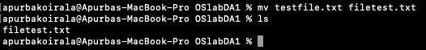

rm:
removes filetest.txt
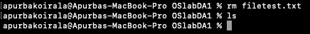

pwd:
displays path to current directory
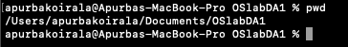

pushd:
pushes current directory to the stack
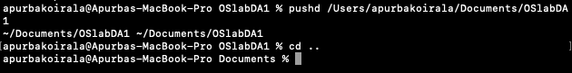

popd: directory is changed back to the previously pushed directory as it is popped
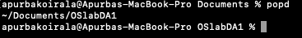

cat: a new file named cat.txt is made, text is entered using the cat command and displayed.
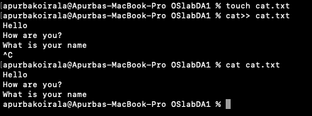

whereis: node location displayed
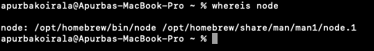

printenv: environment variables of current shell session displayed
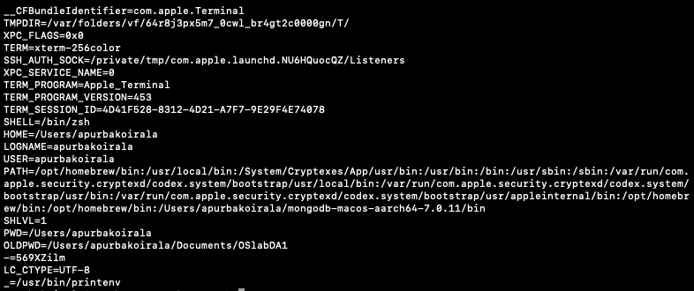

grep: lines containing Hello in cat.txt are shown

head: more text added to text.txt. The first three lines displayed using the head command
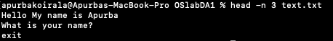

tail: similar to head, last three lines of text.txt displayed using the tail command
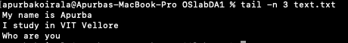
QUESTION– II – Shell Scripts

1. Write Script to see current date, time, username, and current directory
SOURCE CODE:
date; who; pwd;

OUTPUT :
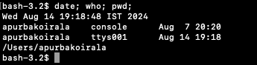

2. How to write shell script that will add two numbers, which are supplied
as command line argument, and if this two numbers are not given show
error and its usage.

SOURCE CODE:

read -p "Enter the first number: " n1
if [ -z "$n1" ]; then
echo "Error: Number not entered"
exit 1
fi
read -p "Enter the second number: " n2
if [ -z "$n2" ]; then
echo "Error: Number not entered"
exit 1
fi
sum=$((n1 + n2))
echo "The sum of the two values is: $sum"

OUTPUT :
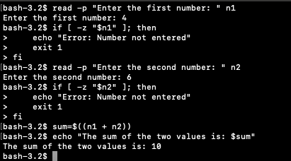

3. Write Script to find out biggest number from given three nos. Numbers
are supplied as command line argument. Print error if sufficient
arguments are not supplied.

SOURCE CODE:

#!/bin/bash

read -p "Enter the first number: " n1
read -p "Enter the second number: " n2
read -p "Enter the third number: " n3
if [ -z $ “n1” ] -o [ -z $ “n2”] -o [ -z $ “n3”]; then
echo "Error: Sufficient arguments are not supplied."
fi
if [ "$n1" -gt "$n2" ] && [ "$n1" -gt "$n3" ]; then
echo "$n1 is the biggest number"
elif [ "$n2" -gt "$n1" ] && [ "$n2" -gt "$n3" ]; then
echo "$n2 is the biggest number"
else
echo "$n3 is the biggest number"
fi

OUTPUT :
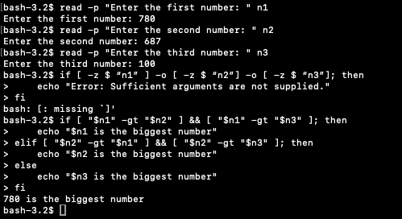
4. Write script to print the following numbers as 5,4,3,2,1 using while loop.

SOURCE CODE:

read -p "Enter a number: " n
if ! [[ "$n" =~ ^[0-9]+$ ]]; then
echo "Error: Please enter a valid positive number."
exit 1
fi
while [ "$n" -gt 0 ]; do
echo "$n"
n=$((n - 1))
done

OUTPUT :
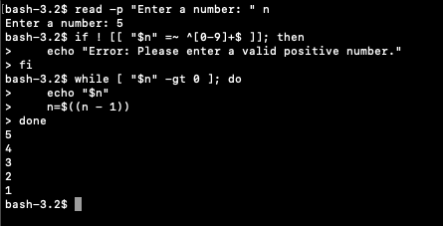

5. Write Script, using case statement to perform basic math operation as
follows: + addition, - subtraction, x multiplication, / division

SOURCE CODE:

read -p "Enter the first number: " n1
read -p "Enter the second number: " n2
read -p "Enter your choice (add, sub, mul, div): " reply
case $reply in
add )
sum=$((n1 + n2))
echo "Sum: $sum"
;;
sub )
sub=$((n1 - n2))
echo "Subtraction: $sub"
;;
mul )
mul=$((n1 * n2))
echo "Multiplication: $mul"
;;
div ) div=$((n1 / n2))
echo "Division: $div"
;;
* )
echo "Error: Invalid operation. Please enter one of +, -, x, /."
;;
esac

OUTPUT :
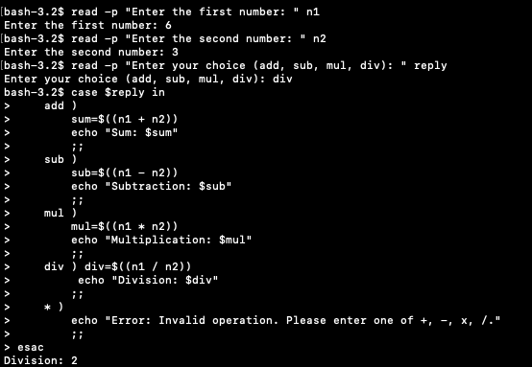

QUESTION 3 – System Calls
1. Write Programs using the following system calls of LINUX operating
system:
a. fork, exec, getpid, exit, wait, close, opendir, readdir, stat

SOURCE CODE:
FILE="example.txt"
DIR="."
echo "Hello, world!" > "$FILE"
echo "Parent process ID: $$"
(
echo "Child process ID: $$"
ls -l
exit 0
) &
wait
echo "Child process has finished."
echo "Contents of directory '$DIR':"
for entry in "$DIR"/*; do
if [ -d "$entry" ]; then
echo "Directory: $entry"
elif [ -f "$entry" ]; then
echo "File: $entry"
fi
done
echo "Status of file '$FILE':"
stat "$FILE"
rm "$FILE"
echo "Script execution completed."

OUTPUT : 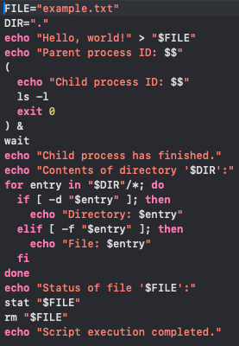
RESULTS: 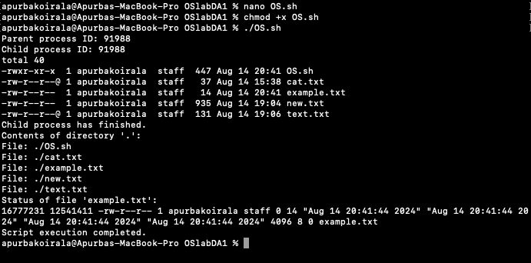

2. Write Programs using I/O system calls of LINUX operating system:
open, read, write etc.

SOURCE CODE:
FILE="example.txt"
echo "Hello, system calls!" > "$FILE"
echo "Data written to $FILE"
echo "Reading from $FILE:"
cat "$FILE"
echo "Content of $FILE:"
while IFS= read -r line; do
echo "$line"
done < "$FILE"
rm "$FILE"
echo "$FILE has been removed."
echo "Script execution completed."

OUTPUT : 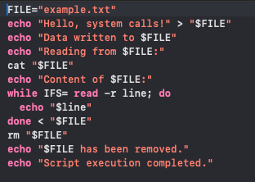
RESULTS: 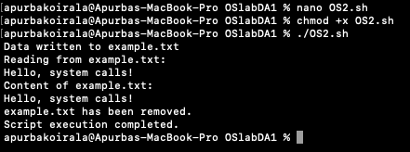

3. Write Programs using C to simulate LINUX commands

a. ls command,

SOURCE CODE:

#include <stdio.h>
#include <stdlib.h>
#include <dirent.h>
#include <sys/types.h>
int main() {
DIR *dir;
struct dirent *entry;
dir = opendir(".");
if (dir == NULL) { perror("opendir"); return EXIT_FAILURE; }
while ((entry = readdir(dir)) != NULL) { printf("%s\n", entry->d_name);
}
closedir(dir);
return EXIT_SUCCESS;
}

OUTPUT : 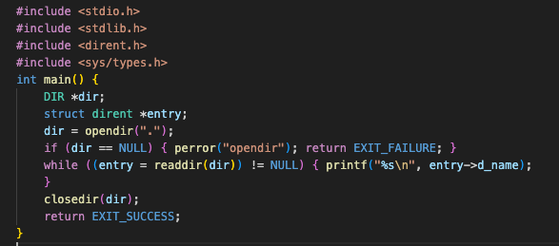
RESULTS:
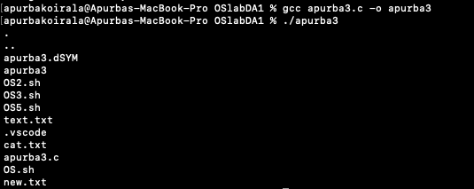

b. grep command
SOURCE CODE: #include <stdio.h>
#include <stdlib.h>
#include <string.h>

#define BUFFER_SIZE 1024

int main(int argc, char *argv[]) {
if (argc != 3) {
fprintf(stderr, "Usage: %s <pattern> <file>\n", argv[0]);
return EXIT_FAILURE;
}

const char *pattern = argv[1];
const char *filename = argv[2];
FILE *file;
char line[BUFFER_SIZE];

file = fopen(filename, "r");
if (file == NULL) {
perror("fopen");
return EXIT_FAILURE;
}

while (fgets(line, sizeof(line), file) != NULL) {
if (strstr(line, pattern) != NULL) {
printf("%s", line);
}
}

fclose(file);
return EXIT_SUCCESS;
}

OUTPUT: 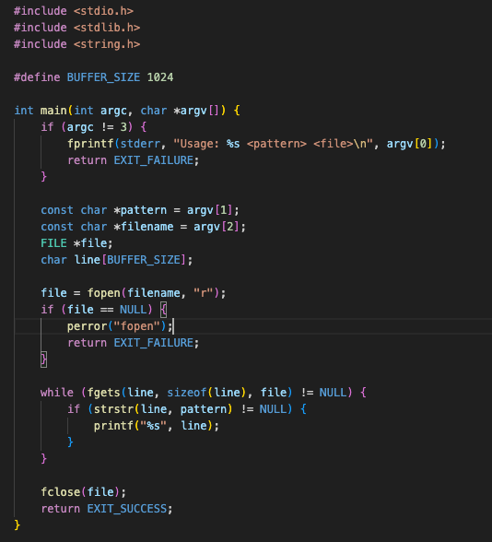

RESULTS: 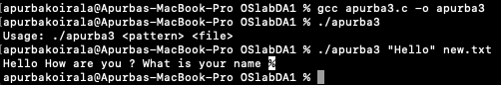

4. Create a file with few lines, write a C program to read the file and delete
the spaces more than one in the file.

SOURCE CODE:
#include <stdio.h>
#include <stdlib.h>
#include <ctype.h>
#define BUFFER_SIZE 1024
void remove_extra_spaces(FILE *input, FILE *output) { char ch; int in_space = 0;
while ((ch = fgetc(input)) != EOF) { if (isspace(ch)) { if (!in_space) { fputc(' ', output); in_space = 1;
}
} else { fputc(ch, output); in_space = 0;
}
}
}
int main() {
FILE *input_file, *output_file;
input_file = fopen("cat.txt", "r"); if (input_file == NULL) { perror("Failed to open input file"); return EXIT_FAILURE;
}
output_file = fopen("new.txt", "w"); if (output_file == NULL) { perror("Failed to open output file"); fclose(input_file);
return EXIT_FAILURE;
}
remove_extra_spaces(input_file, output_file); fclose(input_file); fclose(output_file);
printf("Processed file written to output.txt\n"); return EXIT_SUCCESS;
}

OUTPUT :
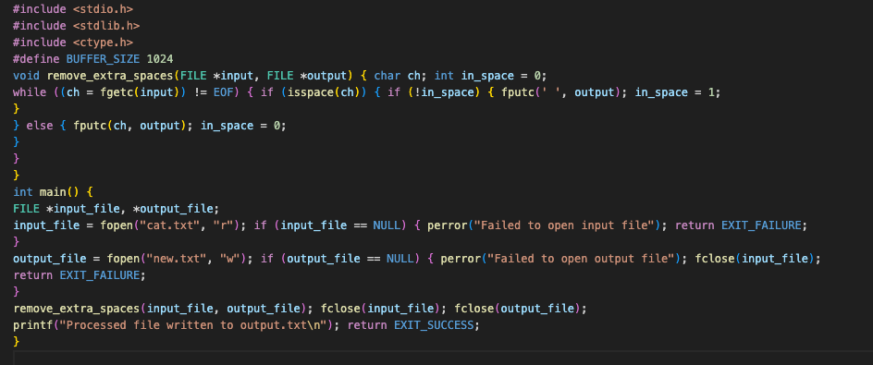
Cat.txt

New.txt


5. Write a program:
a. To create parent & child process and print their id.
b. To create a zombie process.
c. To create orphan process.
d. To make the process to sleep for few seconds.
e. Implement the program to pass messages using pipes.

SOURCE CODE: echo "Task a: Creating parent and child process"
(
echo "In child process (PID $$)"
echo "Child process ID: $$"
sleep 5
) &

CHILD_PID=$!
echo "Parent process waiting for child process to finish."
wait $CHILD_PID
echo "Child process has finished."

echo "Task b: Creating a zombie process"
(
echo "In zombie process (PID $$)"
sleep 30 & ZOMBIE_PID=$!
echo "Zombie process ID: $ZOMBIE_PID"
) &
sleep 5

echo "Task c: Creating an orphan process"
(
echo "In orphan process (PID $$)"
sleep 60 & ORPHAN_PID=$!
echo "Orphan process ID: $ORPHAN_PID"
sleep 60
) &

echo "Task d: Making the process sleep"
sleep 10
echo "Sleep complete."

echo "Task e: Using pipes"
mkfifo mypipe
echo "Message from the parent process" > mypipe &
cat mypipe
rm mypipe

wait
echo "All tasks completed."
OUTPUT : 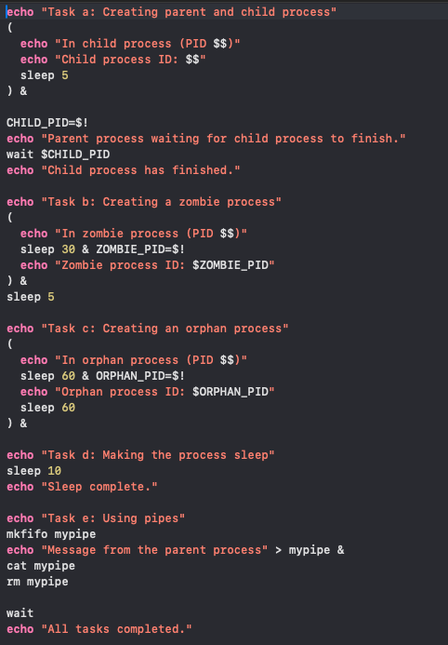
RESULTS: 